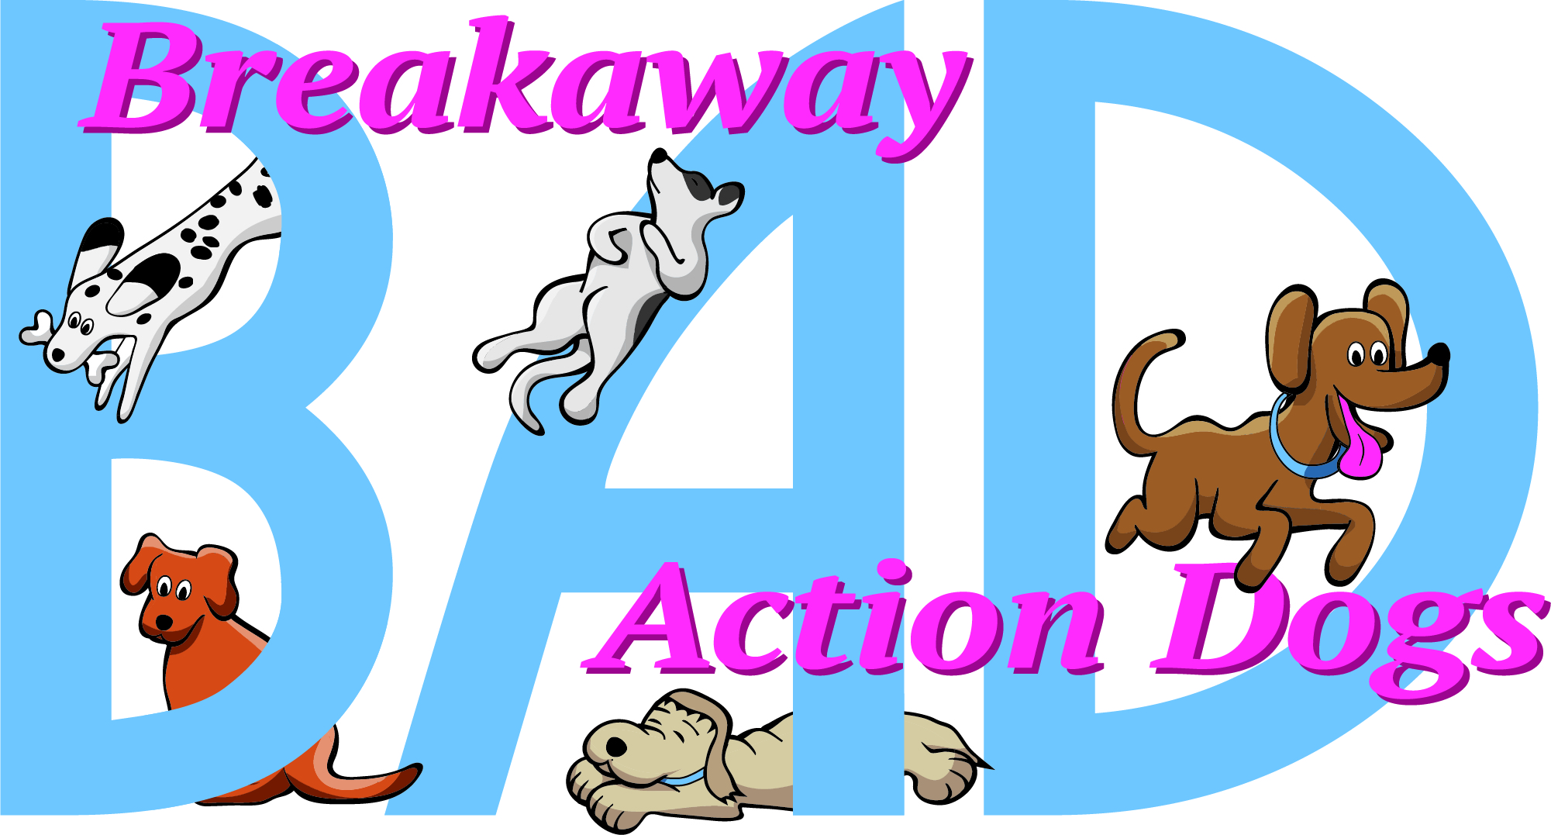
Breakaway Action Dogs  February 5 & 6, 2022  900 East Patrick St, Bldg 8  Frederick, Md  Judge:  Carole Daggett  Double run or Single Run  or Mixed Trial format:  Double Run format  Building and Ring Surface info:  Indoor on Artificial Turf  Contact Surface:  Rubberized slats  Crating Set up times:  Crating building opens at 7:00 AM  Briefing at:  8:30 AM  First dog on the line at:  Following walkthrough and briefing | Preliminary Class Order:  May change depending on weather, judges preference, time or number of entries  Saturday  Class: Double Run Single Run  Touch N Go 2  Weavers 2  Tunnelers 2  Grounders 2  Sunday  Class: Double Run Single Run  Grounders 2  Tunnelers 2  Weavers 2  Touch n Go 2

Entries Open on:  When premium is posted  Entries Close on:  January 27, 2022 or when limit is reached  Changes and move ups must be submitted no later than January 31, 2022  Crating:  NO CRATING ALLOWED IN THE TRIAL BUILDING. Exhibitors will be allowed to set up a chair at ringside.  Crating is out of your car or our  Heated/Air conditioned building adjacent to the trial building. At least 10’ spacing provided for setting up your crating station. Face masks are recommended for everyone to be worn inside the buildings at all times. They are required for anyone not vaccinated. You may run your dog without a mask. Floor protection must be used under crates.  Dog potty area next to the building.  Entry Limits:  400 runs per day  Move ups:  There will be no same day MOVE-UPS: however, if you title on Saturday, you may move up to the next level on the following day.  Day of show Entries:  NO Day of Show entries accepted at this trial.  Refunds:  Should we decide to cancel due to Covid infection rates in our area, then all entry payments will be shredded.  There will be no refunds for entries in the event a dog and/or handler are dismissed from competition regardless of the reason for such dismissal.  A withdrawal from the competition after the closing date due to an injury and/or illness and/or a bitch coming into season after the closing date will be eligible for a refund up to 75% of the total entry fee paid. A veterinarian's notice of injury or illness may be required for a refund. | Show Committee  Trial Chairperson - Jean Wilkins  Email (preferred) wilkinspsck@comcast.net 410-379-1519  Trial Secretary - Laurie Muller  Email (preferred) 4bigpaws@comcast.net 301-471-3410  Chief Course Builder Jean Wilkins  Chief Ring Steward TBD  Equipment Manager Breakaway Action Dogs  Confirmations:  Confirmations will be emailed. Please check for accuracy. An Assumption of Risk form must be signed at the trial before you will be allowed to participate.  Food info:  No food will be provided at the trial.  Fast food restaurants are 5 minutes away.  Volunteer info:  We will be relying on exhibitors to help with course building and running the ring. A sign up board will be set up for you to choose times and/or classes that you are able to help with.  Awards and Ribbons:  Qualifying and placement ribbons will be available for dogs that earn a qualifying run. Special rosettes are awarded for any titles earned.  Equipment info:  24” Weaves  Electronic timers  New Contact Equipment with rubberized slatted surface
Jump Height Info:
MEASURING
Measurement forms may be obtained at:
https://www.nadac.com/WPsite/wp-content/uploads/2021/06/Permanent-Height-Card-form-6.4.21.pdf
Dogs which require measuring:
Dogs in the Proficient Category, Novice, Open or Elite jumping 4”, 8”, 12” or 16”

Dogs which do not need to be measured:
Dogs jumping 16” in the Veteran or Junior Handler Division
Dogs jumping 20”
Dogs in the Skilled Category
Dogs with a permanent height card
Dogs listed on the Height Exemption List
JUMP HEIGHTS
There are four Standard Division-Proficient jump heights: 8”, 12”, 16”, and 20”.
There are four Standard Division-Skilled jump heights: 4”, 8”, 12”, and 16”.
There are four jump heights for the Veterans and Junior Handler divisions: 4”, 8”, 12”, and 16”.
Please see the NADAC Rulebook for the full jump height table

Brief Summary of Rules:
Please refer to www.nadac.com for a full explanation of all NADAC rules and up to date information.

- Please note that NADAC trials should provide a safe and fun environment for both exhibitors and their dogs.
- Aggressive dogs will not be tolerated and will be excused from the trial.
- The show committee has the right to refuse any entry. Anyone not currently in good standing with NADAC will not be allowed to enter this trial.
- Exhibitors, through submission of entry, acknowledge that they are knowledgeable of NADAC rules and regulations, and agree to abide by all rules in effect at the time of this trial.
- No entry fee will be refunded if the trial cannot open or be completed by reasons of riots, civil disturbances, fire, acts of God, public emergency, an act of a public enemy, or any other cause beyond the control of the organizing committee.
- Checks not honored by the bank do not constitute a valid entry fee. There will be a $25.00 service charge for bank returned checks.
- Dog must be registered and have a valid registration number before entries will be accepted. https://www.nadac.com/register-your-dog/
- A copy of the current Exhibitors Handbook may be downloaded free from the NADAC web site: www.nadac.com
- Bitches in heat, lame, or blind dogs are ineligible for entry, as is any dog with a deformity which may cause a judge to not be able to reasonably assess the dog’s ability to function and perform agility obstacles safely, and in a manner that is in the best interest, health and welfare of the dog.
- No food, clickers, or other aids or devices shall be permitted on the course or within 10 feet of the ring. Food or a small non-audible toy can be in a secure container (ziplock bag is acceptable) in your pocket during your run but you cannot indicate to the dog it is there. All handlers may bring a non-audible toy into the ring for training purposes. They cannot earn a Qualifying score and must declare to the judge they are training before they commence their run. Please read the Exhibitor’s Handbook for more information about toys and training in the ring.
- The sponsoring clubs will not be responsible for the loss or damage to any dog exhibited, or for the possessions of any exhibitor whether the result be accident or other cause. It is distinctly understood that every dog at this event is in the care and control of his owner or handler during the entire time the dog is on the show premises.

Breakaway Action Dogs – February 5 & 6, 2022
Make Checks Payable to: Breakaway Action Dogs
Send entries to: Laurie Muller 2702 Monocacy Bottom Rd. Adamstown, MD 21710

Owner |  |  |  |  |  | Dog
Name |  |  |  |  |  | Call Name
Address |  |  |  |  |  | NADAC Reg #
City/State/Zip |  |  |  |  |  | Date of Birth
Phone |  |  |  |  |  | Height at Withers
Email |  |  |  |  |  | Breed
Handler, If not owner |  |  |  |  |  | Emergency Contact Name/Phone
PLEASE INCLUDE A COPY OF YOUR DOG’S HEIGHT CARD IF YOU DO NOT HAVE ONE ON FILE.
CATEGORY: PROFICIENT SKILLED
DIVISION: STANDARD VET DOG VET HANDLER JUNIOR HANDLER
I WANT MY DOG TO JUMP: 4 8 12 16 20
Class | Level |  |  |  |  | Day
 | Novice | Open | Elite |  | Saturday |  | Sunday
Grounders |  |  |  |  | Rd 1 Rd 2 |  | Rd 1 Rd 2
Touch n Go |  |  |  |  | Rd 1 Rd 2 |  | Rd 1 Rd 2
Tunnelers |  |  |  |  | Rd 1 Rd 2 |  | Rd 1 Rd 2
Weavers |  |  |  |  | Rd 1 Rd 2 |  | Rd 1 Rd 2
In consideration of the acceptance of this entry, I/we certify that I/we have knowledge of, and are familiar with, and agree to abide by, the Rules and Regulations of NADAC in effect at the time of this trial, and by any additional rules and regulations as approved by NADAC for this trial. I/we certify that the dog entered is not a hazard to persons or other dogs. I/we further agree to be bound by the “Agreement” below.

Number of Total Runs Entered (all dogs): # ___________
□ 1- 8 Runs = $12 each = ___________
□ 9 or more runs = $11 each = ___________
□ Junior Handler = $6 each = ___________

TOTAL ENCLOSED =___________

Owner/Exhibitor: ____________________________________Date______________________
Parent or Legal Guardian of Junior Handler__________________________________________

AGREEMENT
The person who signs this agreement represents that he/she is authorized to enter into this agreement on
behalf of both exhibitor and the owner of entered dog. In considerationof acceptance of this entry:
1.1. As used here "NADAC" means the North American Dog Agility Council, LLC., its members,officers, directors, employees, show chairs, show committees and agents.
1.2. Exhibitor/owner agree to abide by the rules and regulations of NADAC and any other rules and
regulations appearing in the premium for this event.
1.3. Exhibitor/owner certify that the entered dog is not a hazard to persons, dogs or property and that
the entered dog's rabies vaccination is current in accordancewith the requirement of the state in whichthe dog resides.
1.4. Exhibitor/owner acknowledge all hazards presented by the event and the event premises,
including, but not limited to, the condition of the surface, restrooms, security measures or lack of,
electrical appliances, fittings, show rings, parking areas and the presence of unfamiliar animals and
people; exhibitor and owner assume the risk of any harm arising from these.
1.5. Exhibitor/owner releases NADAC (including its respective officers, directors, employees, and
members), Breakaway Action Dogs, Inc (including its officers, directors, members, and event organizing
committee), and Gladhill Properties (including its officers, agents, and employees) and will
defend them and hold them harmless from all present and future loss, injury, damage, claims, demands
and liabilities involving the entered dog, the event or event premises. Without limiting the generality of the
foregoing hold harmless provisions, exhibitor/owner hereby specifically assumes sole responsibility for
and agrees to indemnify and save the aforementioned parties harmless from any and all loss and
expenses (including legal fees) by reason of the liability imposed by law upon any of the aforementioned
parties for damages because of bodily injuries, including death, at any time in consequence of my (our)
participation in this event, howsoever such injury or death may be caused and whether or not the same
may have been caused or may have been alleged to have been caused by negligence of the
aforementioned parties or any of their employees or agents or any other persons

Hotels
Motel 6, 999 West Patrick St., Frederick, MD 21701 301-662-5141
Days Inn, 5646 Buckeystown Pike, Frederick, MD 21704 301-694-6600
Comfort Inn, 7300 Executive Way, Frederick, MD 21704 301-668-7272

Country Inn & Suites, 5579 Spectrum Dr. at Francis Scott Key Mall, Frederick, MD 21703 301-695-2881

DIRECTIONS TO TRIAL SITE

Address: 900 J East Patrick Street, Frederick MD 21701

From I 70 West (Hagerstown) From I 70 East(Baltimore)
Exit 55 SOUTH ST. toward Frederick Fairgrounds. Exit 56– E PATRICK ST (Bowmans Farm Rd) (Rt 144)

Turn RIGHT onto E SOUTH ST. Go ½ mile on E PATRICK ST

Turn RIGHT onto MONOCACY BLVD. Turn LEFT at STTC TIRE

Turn LEFT onto E PATRICK ST (Rt. 144) Follow lane to the last building on the left
1/4 mile turn LEFT at STTC TIRE.
Follow lane to the last building on the left

