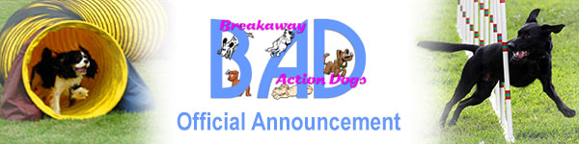
NADAC Virtual Trialing at Breakaway Action Dogs
While we regret we have had to cancel our August and November trials due to the coronavirus pandemic, we are able to offer a setting for NADAC Video Tape Trials.
Breakaway Action Dogs is hosting our first NADAC Virtual Trialing at our facility in Frederick, MD on Saturday, August 29, 2020. This event is being held in our air conditioned building #2.
Pre registration is required. No DropIn registrations will be allowed.
We are limiting this trial to 100 runs total for the day.
Classes offered are Tunnelers and Chances and will be double run format (2 runs for each class). Elite, Open and Novice levels (sorry no Intro). We will be using Nadac’s small courses layouts, “Dory” for this trial.
Sign up for group time slot begins at 8am. A maximum of 4 dogs in each group. The first group walkthrough will begin at 8:30am for Tunnelers. Chances will begin ½ hour after the Tunnelers class is done. If you sign up for Chances then you will receive an email by Friday with a tentative start time for that class.
Fee is $10 per dog per class. So you get 2 runs for that price. Payment will be taken when you sign up for your group time slot.
Recording runs and submitting to NADAC is the responsibility of the exhibitor as is the NADAC fee. We will have someone on hand to record using your device if you need help.
Masks are required at all times, when in the buildings, during runs and on the grounds.
You must crate out of your car.
Bathrooms in the sign up/ practice building #1 will be open for use.
To reserve a slot, email Laurie Muller at 4bigpaws@comcast.net. Include your name, email address, # of dogs you wish to run and classes you wish to enter. A confirmation will be sent to you with final details.
At no additional charge, there will be a practice ring set up in building #1 which is our usual trialing site. Only those signed up for the trial will be allowed in the practice ring. This building is not air conditioned so practice will be available until it gets too hot. Various agility equipment will be set out for you to practice with your dog. Only 1 person is allowed in the ring area at a time. You will be allowed 5 minutes for practice. Sign up for practice time will be available at the sign up table. You may sign up more than once, depending on the demand for time.
Please share this with your friends.

